*COMP 246 --* [*Smart Team: Part C Final Submission*](https://e.centennialcollege.ca/d2l/lms/dropbox/user/folder_submit_files.d2l?db=278043&grpid=480893&isprv=0&bp=0&ou=477093)

Students’ name:

Andrew Trinidad

Caique Bispo Ferreira

# Part C – System Design Document

## Design Patterns



## Design Patterns in the class diagram

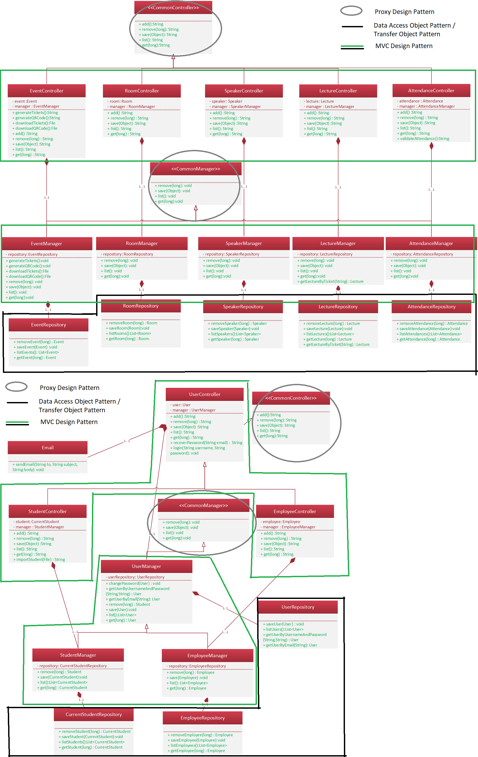



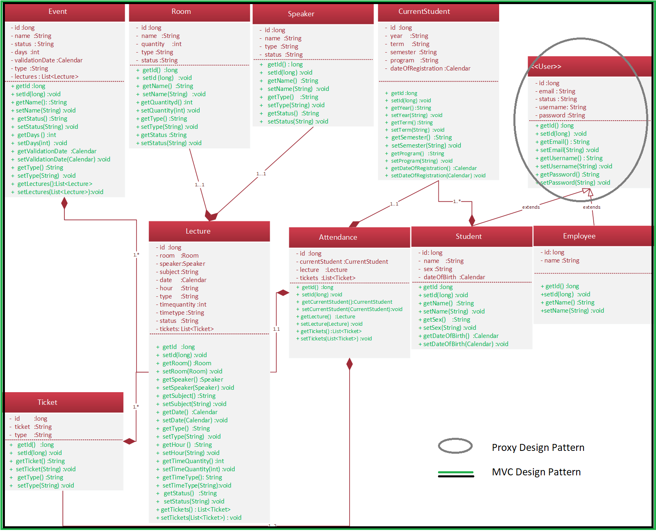

## UI Mock-ups

## 

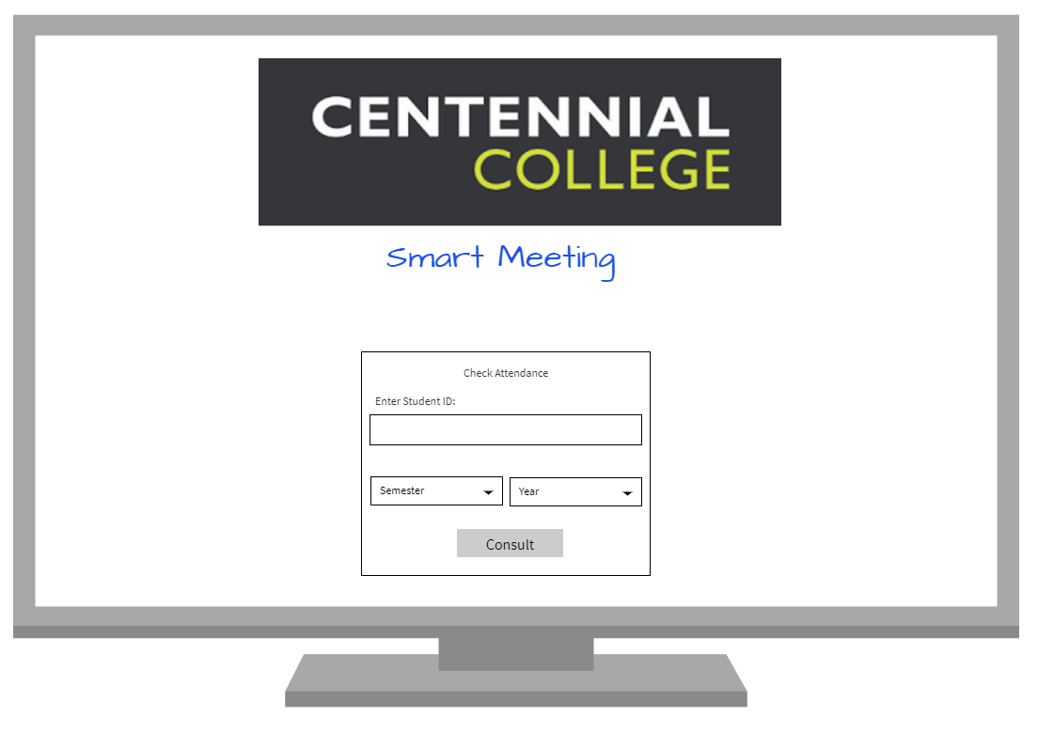

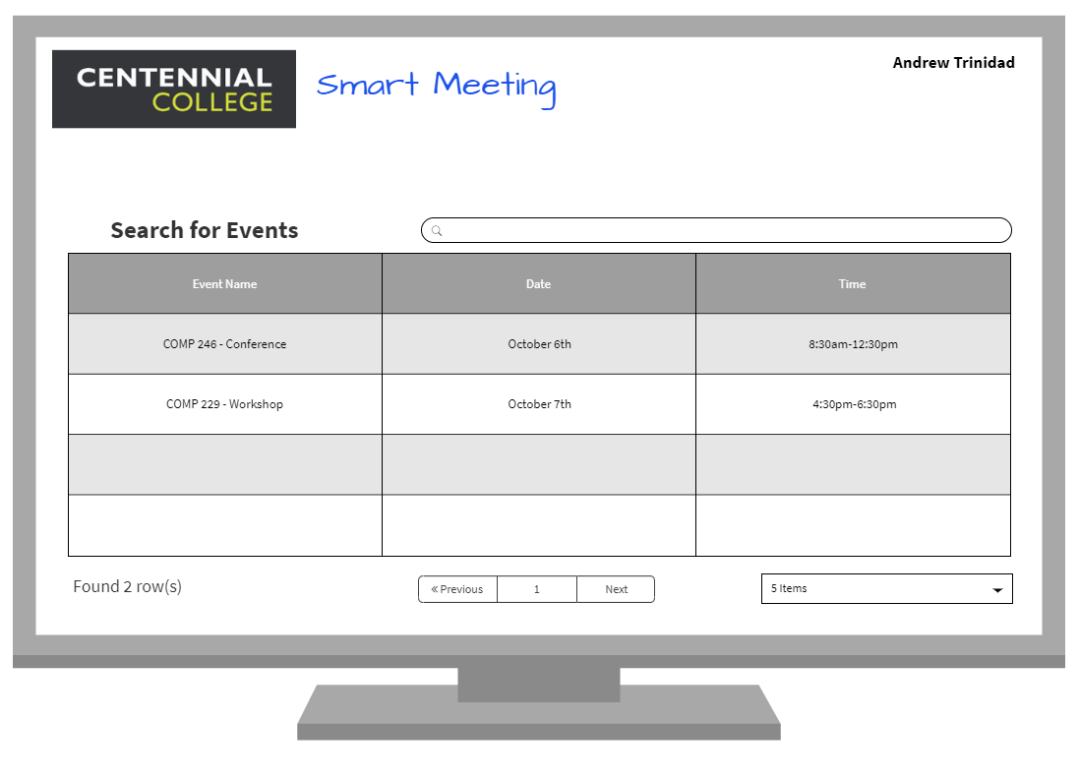

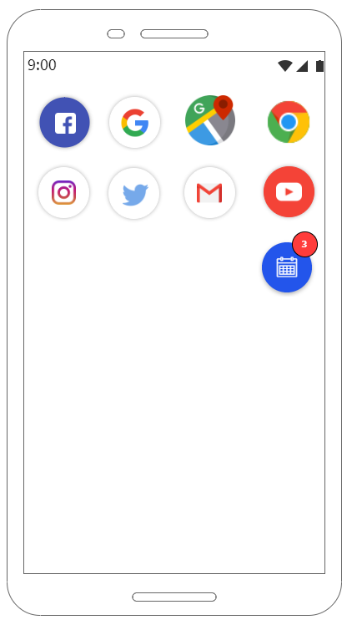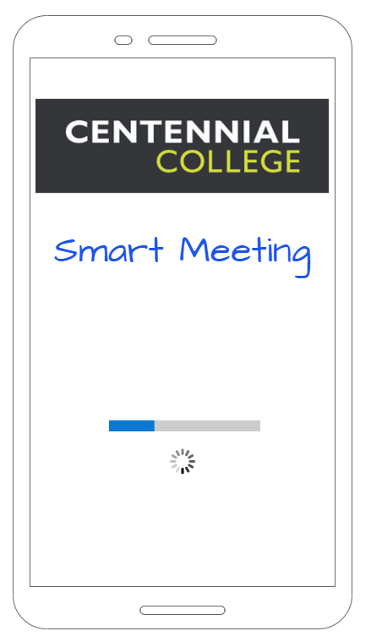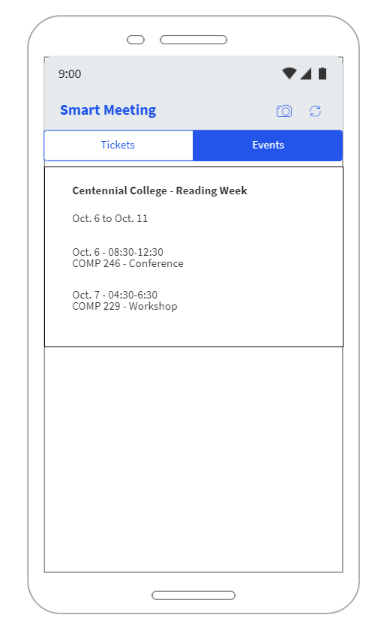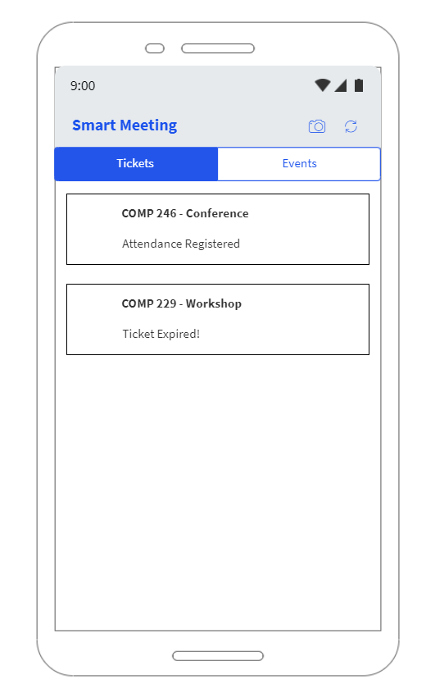

## Component Diagram

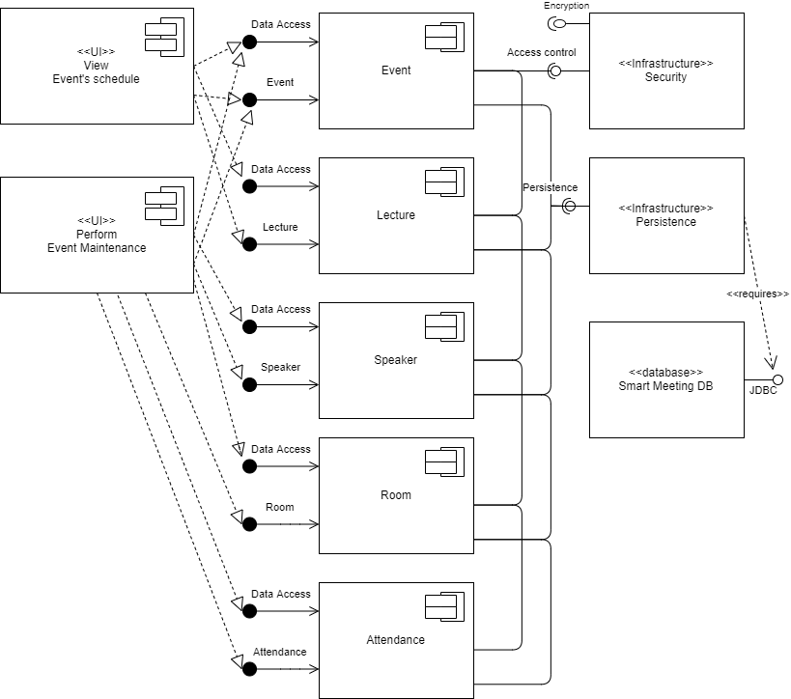

## Deployment Diagram

